
VMware Pro Cloud Service for Private Cloud Infrastructure - VMware Cloud Foundation Operations for logs Installation and Configuration Procedures 9.0

You can find the most up-to-date technical documentation on the Broadcom website at:
https://techdocs.broadcom.com/
Broadcom®
3421 Hillview Ave.
Palo Alto, CA 94304
www.vmware.com
Copyright© 2026 Broadcom® All rights reserved.
Contents
1. Purpose and Assumptions 4
VMware Products and Versions 4
Architecture Model 4
2. Installation and Configuration Procedures 6
Deploying VCF Operations for logs 6
3. References 9
References 9

Purpose and Assumptions
This document provides step-by-step instructions for installing, configuring and deploying the solution for Customer.
This document is written with the assumption that the administrator who uses these procedures is familiar with the products being used. It is not intended for administrators without prior knowledge of the concepts and terminology.

VMware Products and Versions
The following table lists the product versions used in this service. The build numbers here refer to the downloaded installer version of this guide.
Table 1-1. VMware Products and Versions
VMware Product | Version Number
VMware Cloud Foundation | 9.0.1.0The Intelligent Logging and Analytics for VMware Cloud Foundation VMware Validated Solution recommends the following bill of materials for the VMware Cloud Foundation Operations for logs Deployment.
Table 1-2. VMware Cloud Foundation Installed Products and Versions
VMware Product | Version Number
VMware Cloud Foundation for logs | 9.0.1.0 - Build 24960345
- You must use VCF Operations Fleet manager deploy VCF Operations for logs.

Architecture Model
Standardization of software configuration which improves predictability, supportability and speed of delivery. Considering these benefits, VMware has developed VMware Cloud Foundation.
VMware Cloud foundation brings a comprehensive design to an environment that covers everything from hardware configuration to automated software installation and configuration of the entire SDDC. The result is a highly available, scalable and robust platform, that is vigorously tested.
VMware Cloud foundation uses its own customized architecture and adds on VMware Validated Solutions to add functionality as appropriate. This service uses these different architectures as a baseline for deployment.
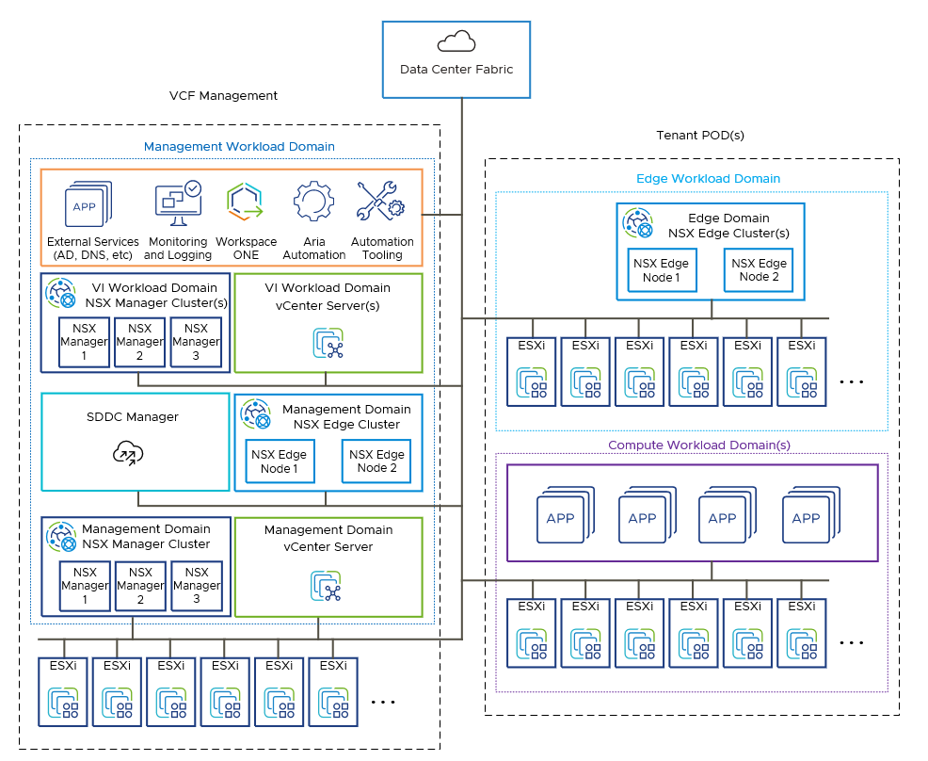

Installation and Configuration Procedures
This section provides step-by-step procedures for common configuration tasks to be performed during the deployment of the product in Customer's environment.

Deploying VCF Operations for logs
VCF Operations for logs is designed to help you collect, analyze, and visualize logs from across your VMware Cloud Foundation platform.
You deploy the VCF Operations for logs appliance by using VCF Operations fleet management
fleet management. This provides:
- Centralized log aggregation: Collect logs from all VCF components, such as vCenter, ESX, NSX, vSAN, VCF Automation, VCF Operations, VCF Identity Broker, VCF Operations for networks, and VCF Operations HCX
- Real-time analytics: Search and filter logs instantly for troubleshooting or auditing.
- Dashboards and alerts: Content packs for VCF components offer pre-built dashboards, alerts, and queries.
Before starting the installation, download the operations-logs binary to the fleet management appliance. See Downloading VCF management components. Then select Fleet Management > Lifecycle and click Add on operations-logs.
The deployment moves through the following stages.
- Deployment
  - Installation type
New Install | Choose this option to perform a fresh installation.
Import | Imports an existing operations-logs 9.0 or later deployment. Not applicable for a new installation.
  - Version: 9.0.0.0
  - Deployment type: Standard or Cluster
- Certificate: Select the certificate for deployment. If no suitable certificate is available, you can generate or import one.
- Infrastructure
  - Select vCenter: Lists management domains for deployment.
  - Select Cluster
  - Select Folder (optional)
  - Select Resource Pool (optional)
  - Select Network
  - Select Datastore
  - Select Disk Mode
  - Use Content Library
- Network
  - Domain Name
  - Domain Search Path
  - DNS Servers: If none exist, then add one and select it.
  - Time Sync Mode: Use NTP Server, Use Host Time
  - IPv4 Details:
    - Default IPv4 Gateway
    - IPv4 Netmask
- Components
  - Enter Component Properties
    - Node Size: Select Small, Medium or Large. Medium is the minimum size recommended for production, testing, or development-type deployments.
    - FIPS Compliance Mode: Default is on. If not needed, turn it off.
    - Certificate: Pre-selected from the previous step. To create a new certificate, click Add Certificate.
    - Set Affinity & Anti-Affinity rule if needed. If selected choose the DRS Anti-Affinity rule type:
      - Keep virtual machines in separate hosts: For anti-affinity, select this rule type.
      - Keep virtual machines in same host: For affinity, select this rule type.
    - Configure Cluster VIP: If set to YES, the Cluster VIP section appears. Enter:
      - FQDN of the of the Cluster VIP
      - IP address that points to the FQDN of the Cluster VIP
    - Upgrade VM Compatibility
    - Always Use English
    - Admin Email
    - Component Password: Select a password to be used by root and admin local accounts. If you do not have a password, click Add Password to create a new one. Password must be a minimum of 15 characters.
    - Time Sync Mode: Preselected.
  - Enter Component/Node properties
    - VM Name
    - FQDN
    - IP Address
- Precheck: If the precheck completes successfully, click Next.
- Summary: To trigger deployment after reviewing the summary, click Submit.

References
The following section lists the documentation resources which were used for this document.

References
For more information, see the following supplemental configuration and administration guides, white papers and best practices documents.

VMware Pro Cloud Services for Private Cloud Solution References
Remember Refine or add any additional links to product documentation
See the VMware Cloud Foundation Documentation (https://techdocs.broadcom.com/us/en/vmware-cis/vcf/vcf-9-0-and-later/9-0.html) for product documentation for Cloud Foundation.
The information is arranged by topics that include the following:
- VMware Cloud Foundation 9.0 Release Notes
- VMware Cloud Foundation Planning and Preparation Workbook
- VMware Cloud Foundation Design Guide
- VMware Cloud Foundation Deployment, Convergence and Upgrade Guide
- VMware Cloud Foundation Building Cloud Infrastructure Guide
- VMware Cloud Foundation vSphere Guide
- VMware Cloud Foundation vSAN Guide
- VMware Cloud Foundation NSX Guide
- VMware Cloud Foundation Lifecycle Management Guide
- VMware Cloud Foundation Fleet Management Guide
- VMware Cloud Foundation Infrastructure Operations Guide
- VMware Cloud Foundation Workload Monitoring and Observability Guide
- VMware Cloud Foundation vSphere Supervisor Platform Guide
- VMware Cloud Foundation Security and Compliance Guide
- VMware Cloud Foundation API Reference Guide
VMware Validated Solutions Guides:
- <Add as apporpriate>

